**DESIGN AND ANALYSIS OF ALGORITHMS**

**CSA0619**

**NAME:K.SHANMUKHA PRIYA**

**REG NO:192011233**

**EXPERIMENT NO 1**

# Write a program to Print Fibonacci Series using recursion.

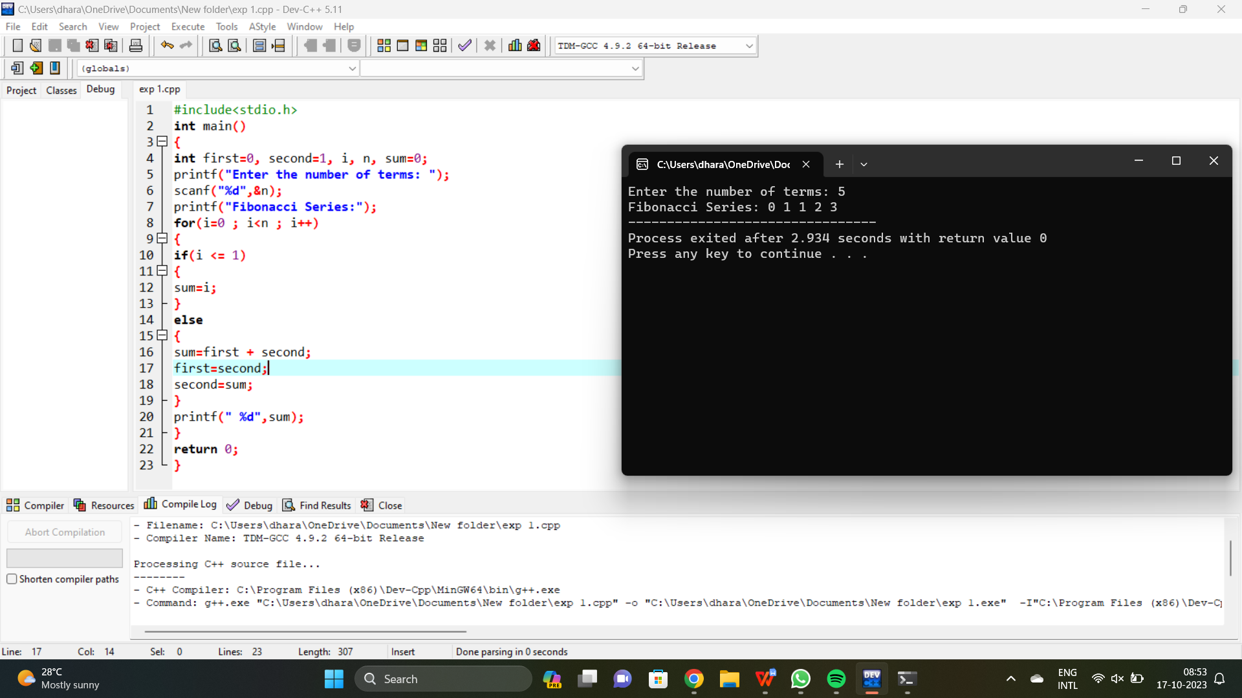

**EXPERIMENT NO 2**

# Write a program to check the given no is Armstrong or not.

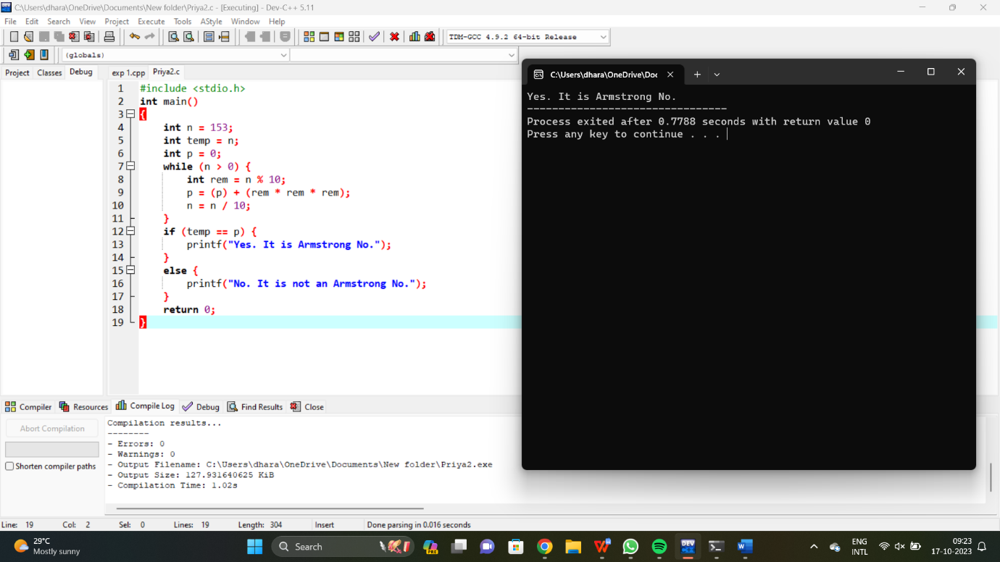

**EXPERIMENT NO 3**

# Write a program to find the GCD of two numbers .

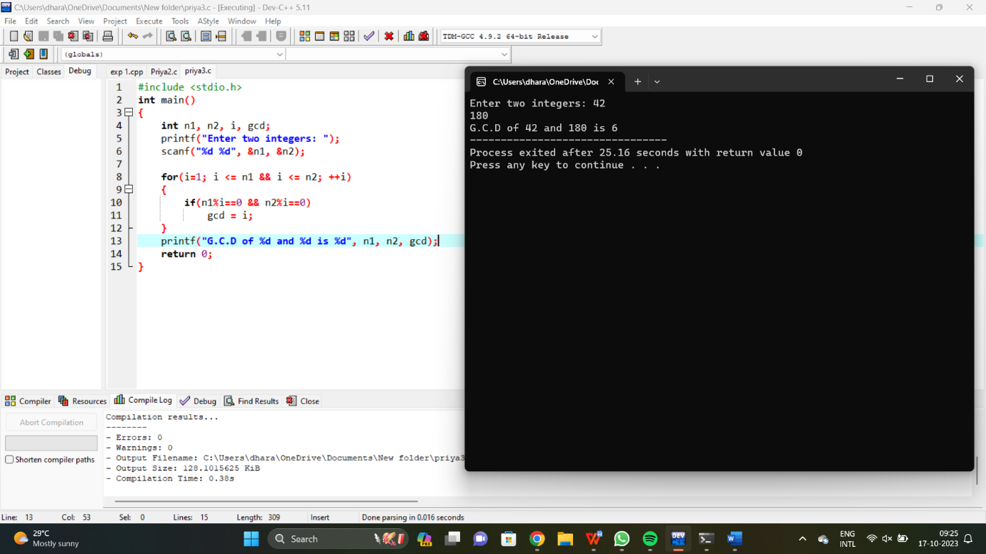

**EXPERIMENT NO 4**

# Write a program to get the largest element of an array.

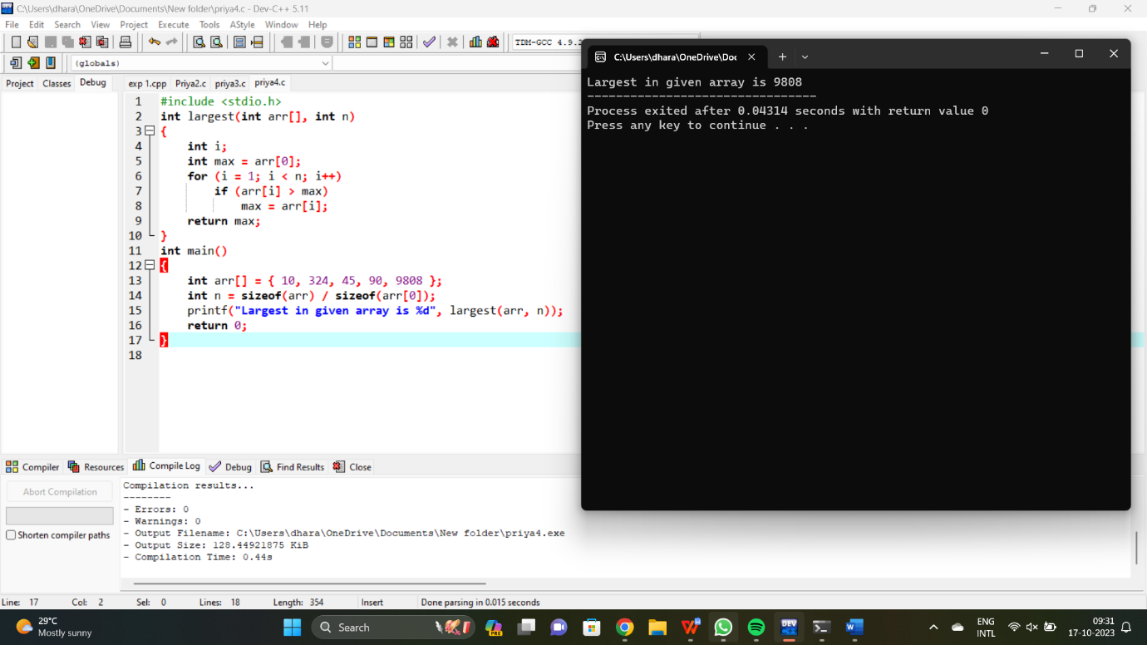

**EXPERIMENT NO 5**

# Write a program to find the Factorial of a number .

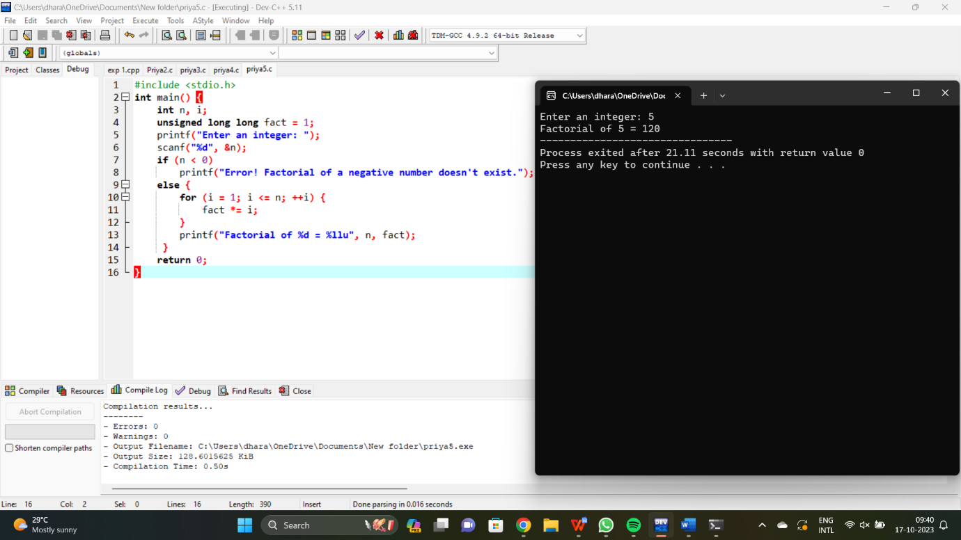

**EXPERIMENT NO 6**

# Write a program to check a number is a prime number or not .

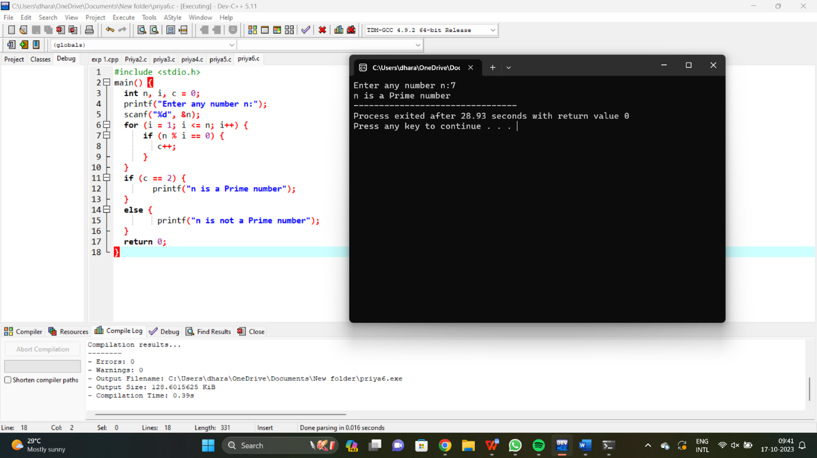

**EXPERIMENT NO 7**

# Write a program to perform Selection sort.

**EXPERIMENT NO 8**

# Write a program to perform Bubble sort

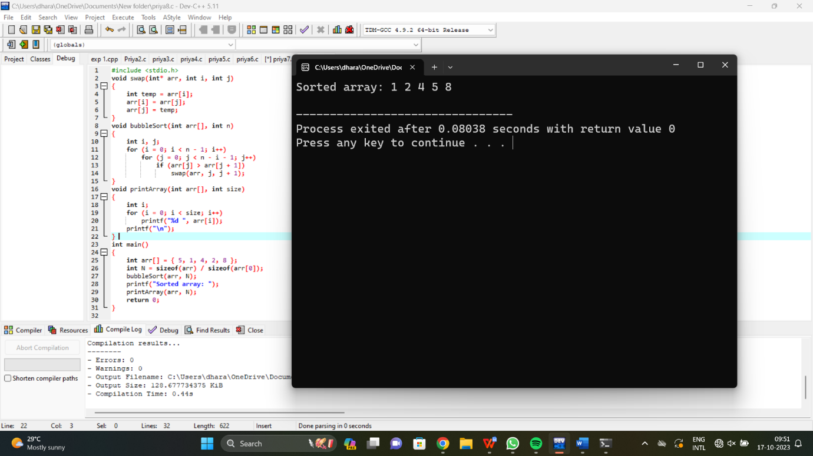

**EXPERIMENT NO 9**

# Write a program for to multiply two Matrix

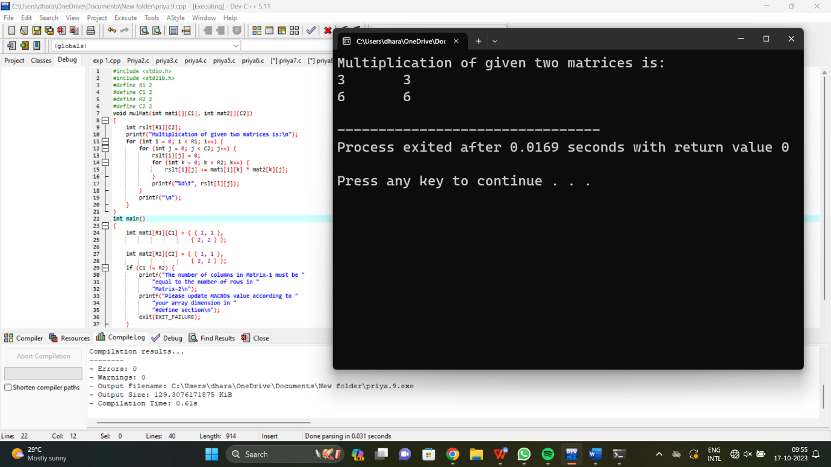

**EXPERIMENT NO 10**

# Write a program for to check whether a given String is Palindrome or not

